**Project Report Template**

**INTRODUCTION**

**TEAM I’D:** NM2023TMID40049

**TEAM LEADER**

J. Bhuvaneshwari – 6EID68AS00F31588A0C4365F2790AID

**TEAM MEMBERS**

M. Barathi -5971FFF9E2CE510BD62406BADE985968

Gnanapriya-ECO8C5EFA98DE92B24DEE7275398C

Karpagavalli-BBFCFD10D6BB294B7BC421DFC93D77CC

1. **Problem definition & Design thinking**

Empathy map

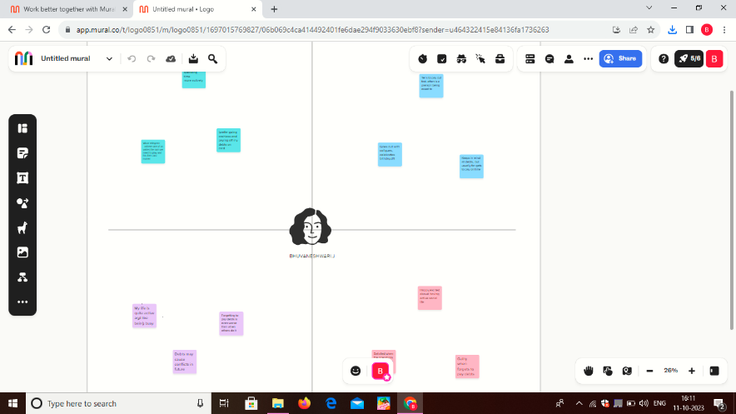

Ideation & brainstorming map

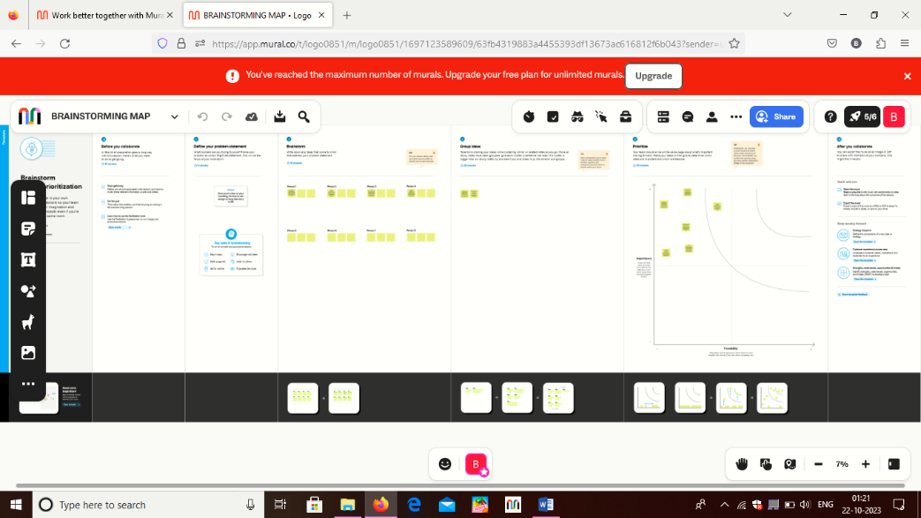

3 Result



4 Advantages & Disadvantage

* + - Endurance and stamina
    - Physical fitness

5 Applications

* It’s the Foundation of your Brand Identity

6 conclusion

* These are the things we have done this project.